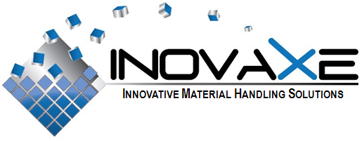

FOR IMMEDIATE RELEASE

Contact:
Inovaxe Corp.
Deerfield Beach, FL
945.531.1363
E-mail: info@inovaxe.com
www.inovaxe.com

See Inovaxe’s Newest Handling and Inventory Control Systems at IPC/APEX 2011

DEERFIELD BEACH, FL — February 2011 — Inovaxe, a world leader and provider of innovative material handling and inventory control systems, will exhibit its latest storage and handling systems in Booth #764 at the upcoming IPC/APEX conference and exhibition, scheduled to take place April 12-14, 2011 at the Mandalay Bay Resort & Convention Center in Las Vegas.

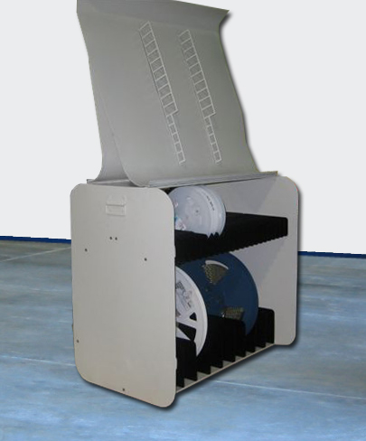
Continuing the Inovaxe philosophy of inventory control through single package/single location, Inovaxe will showcase the innovative Suitcase-Sized Kit Cart. The system provides non-dedicated, high-density, flexible component package storage and Web-based inventory control. The suitcase measures 22"L X 22.75"H X 15.25"W.

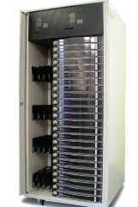
The Suitcase-Sized Kit Cart is designed to replace the complete SMT kitting function for the production floor and can also be utilized for inventory purposes with New Product Introduction (NPI). The system, in concert with the Web-based software, provides location, inventory accuracy and correct component validation for feeder loading and replenishment.

The NPI Award-winning InoCart MSD unit and the InoCart two-bay Material Handling System also will be on display at the show. New Web-based software with additional features and controls promote unparalleled inventory accuracy within the conventional stockroom, the lean manufacturing/floor stocked discipline and WIP environments.

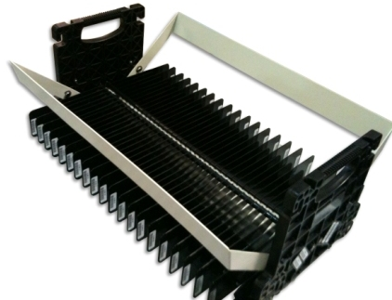
On display for the first time, Inovaxe will debut its new portable InoKit unit, an ultra lean solution for the acquisition and handling of “C Parts.” Inovaxe proposes that through its portable InoKit carrier and associated software, it can reduce the high cost of acquisition and handling of “C parts” while eliminating shortages on the production floor. The portable InoKit carrier can be delivered directly to SMT machines with easy identification for placement into production. Inovaxe proposes that users assign the penny parts to its program as part of a sub-assembly or group of part numbers. At the customer’s request, Inovaxe will ship the parts (sub-kit) packaged in its proprietary InoKit carriers within 48 hours.

For more information about any of Inovaxe’s innovative material handling systems, stop by Booth #764 at the show or visit www.inovaxe.com.

###
About Inovaxe Corp.
Inovaxe Corporation is focused on delivering innovative production and inventory management solutions to the electronics industry. The Company’s product offering includes ambient air and MSD Material Storage Hardware (InoCart), a Supply Chain Management System (InoVision) and a Procurement Program (InoSource). For more information and a demonstration of Inovaxe products, visit www.inovaxe.com.

